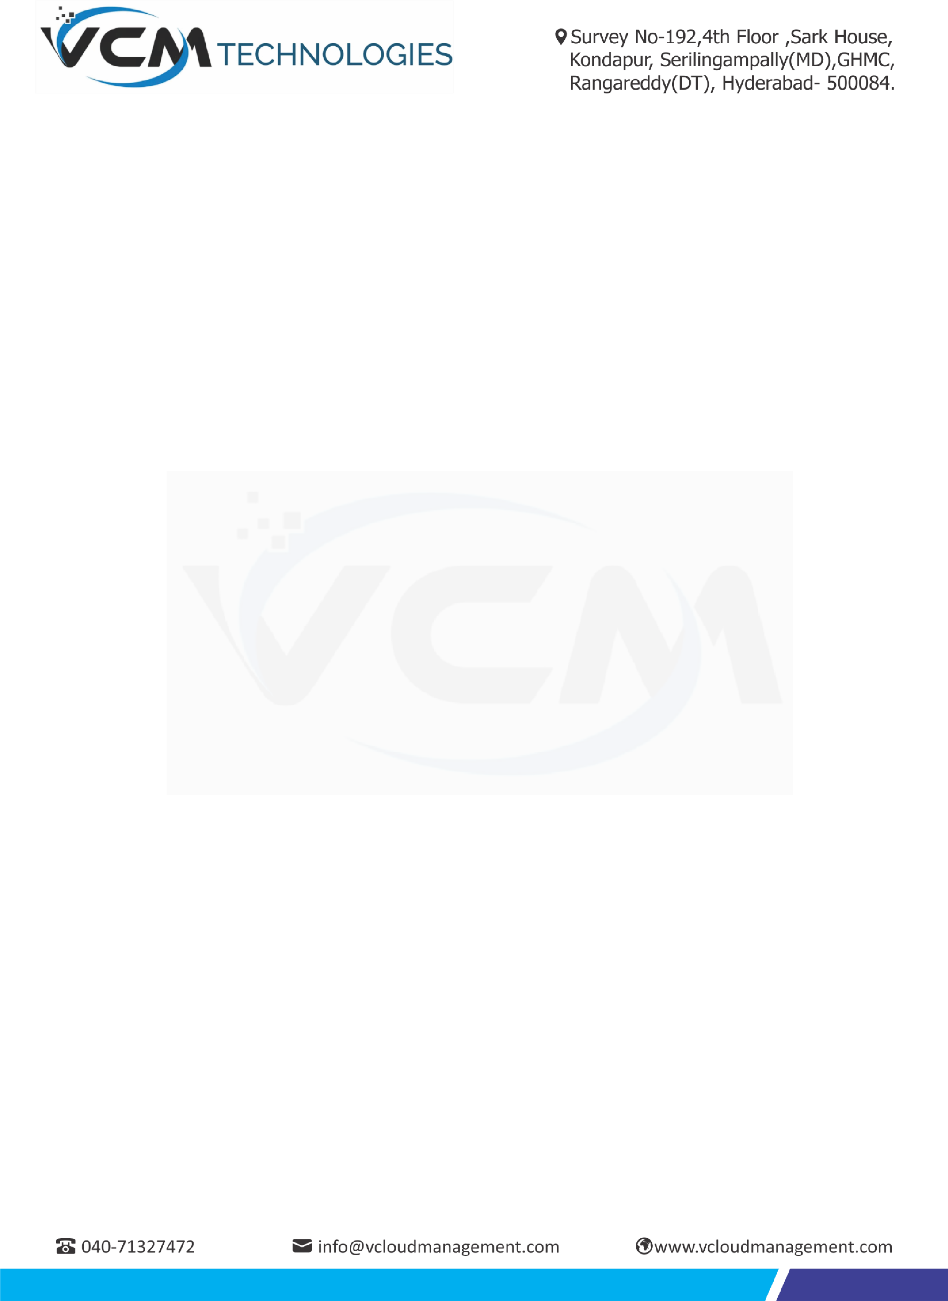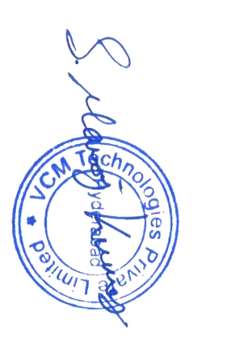

**04**

**February 2020**

**Nooka Praveen Palacharla,**

**Emp Id:**

**VCM**

**-**

**1754**

**Support Engineer**

**Relieving**

**Letter**

This has reference to your resignation letter. This is to inform you that your resignation

has been accepted and you

ar

e relieved from the services of

**VCM Technologies**

on the

close of

working hours on

**04**

**February 2020.**

You are requested to deposit the company Id and any other company property entrusted

to you during your employment with us.

We wish you all

success in your future endeavours

.

Yours truly,

**For**

**VCM TechnologiesP**

**VT LTD**

**.**

**Manoj Kumar.S**

**Sr.**

**HR**

**Man**

**a**

**ger**